dentalaegis > Inside Dentistry - October 2012 > Air Abrasion Enhanced Multi-Surface Bonding
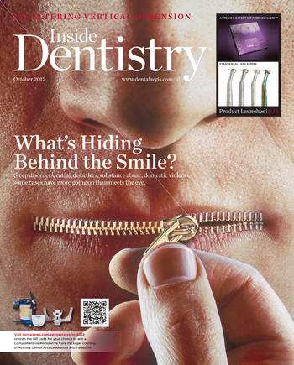

Inside Dentistry

October 2012, Volume 8, Issue 10
Published by AEGIS Communications

Air Abrasion Enhanced Multi-Surface Bonding
Tribochemical treatment of metal and zirconia improves bond strength.
By Marc Gottlieb, DDS | Michael D. Nelson, DDS
Air abrasion with silicon-coated aluminum-oxide particles allows enhanced bonding to metal and zirconia surfaces through tribochemical treatment of the substrate. In cases with multiple substrates (eg, metal, ceramic, resin, enamel, and dentin), preparation with this encapsulated aluminum oxide simplifies bonding and results in stronger bonds to all surfaces.
It is an established fact that acid-etching enamel and ceramic surfaces increases the surface area and improves bond strength. The dilemma in dentistry is how to condition zirconia and metal to achieve the same result. Particularly challenging is conditioning zirconia and metal in the presence of dissimilar materials, eg, metal, porcelain, enamel, and/or dentin. While it is possible to improve bond strengths to metal by tin plating or applying 10-methacryloxydecyl dihydrogen phosphate (MDP), multiple surfaces must be prepared, conditioned, bonded, and restored simultaneously. The ability to treat all surfaces as one similar surface makes bonding faster, easier, better, and less expensive. Therefore, tribochemically enhanced bonding should interest every practicing dentist.
Clinical success depends not only on optimal marginal adaptation but also bonding durability and strength.¹ Dentistry often borrows technology from the aerospace and automotive industries to find a solution. Tribochemical treatment of zirconia and metal allows the dentist to bond composites to these materials, opening up a host of new treatment possibilities in restorative dentistry.
Tribochemistry is the study of the chemical and physicochemical reactions enhanced by friction or mechanical collisions. Tribochemical treatment of the metal or zirconia surface functions as a mechanical catalyst to improve a physical or chemical reaction. Micro-etching a surface is commonly referred to as “sand blasting” with 27-µm or 50-µm aluminum-oxide particles. To tribochemically treat a surface, 30-µm silica-coated alumina particles are placed into a micro-etcher media jar and then sprayed against the surface. This process is analogous to shooting Peanut M&Ms onto a surface. The candy coating is analogous to glass, and the peanut is the aluminum-oxide particle. When etching the surface, the outer, silica “candy coating” is tribochemically attached to the metal or zirconia surface. The aluminum oxide “peanut” falls off. According to a conversation the authors held with Mr. Greg Dorsman, senior chemist at Danville Materials, Inc., “the outside layer is glass and the inside is stone. When the particle hits the surface, glass is embedded into it and the alumina stone falls away. The local energy of impact is so high that the temperature reaches 5,000°C. This should be more than enough to at least partially melt the glass and coat the surface. Silane chemically bonds to glass and resins bond to the silane.”
The surface is treated exactly the same way you would treat the freshly etched surface of a porcelain veneer. SilJet by Danville Materials (www.danvillematerials.com) and the CoJet™ System manufactured by 3M ESPE (www.3mespe.com) are commercial products comprised of 30- µm silica-coated aluminum-oxide particles. Both companies offer complete kits to repair and improve the bond to zirconia or any other metal surface. Tribochemical application of the silica coating to the inside of zirconia crowns improved the bond strength of self-adhesive resin cement to zirconia.²
Dentists like to see how a product or technique works in clinical practice. It is hard to show the resin cement bond to the inside surface of a zirconia crown or a cast post but very easy to demonstrate how to perform a porcelain-fused-to-metal (PFM) repair. The following two clinical cases demonstrate the clinical application of tribochemical adhesion using SilJet.

Case 1
This patient suffered a traumatic injury fracturing the porcelain off the incisal one third of the PFM abutment, tooth No. 27, on a 2-unit cantilevered bridge (Figure 1). It is possible to reshape the remaining porcelain, treat the surface with hydrofluoric acid, and then apply a silane-coupling agent. This will chemically bond the resin to the ceramic material but not the exposed metal. Placing hydrofluoric acid inside the mouth can be hazardous, so it was decided to reshape the fractured porcelain using only air abrasion and tribochemically treating the entire surface with SilJet (Figure 2). A silane-coupling agent was rubbed onto the surface to activate the silica-coated particles on the surface. The exposed metal was then blocked out using a flowable composite opaquer that chemically bonds to the tribochemically treated metal surface (Figure 3). Finally, a thin layer of a microhybrid composite, shade A2, was applied to obtain the proper shape and contour (Figure 4).

Case 2
In an ideal world it would be nice to practice ideal dentistry, but today many patients need to patch or repair a problem until their financial or medical situation improves. This patient requested a creative solution to repair tooth No. 4. The X-ray revealed an asymptomatic endodontically treated tooth with a short fill and screw-type post, a virtual dental Pandora’s box (Figure 5). His chief complaint was that the brand new crown was broken and created the appearance of a black hole in his mouth (Figure 6). This tooth was modified and recontoured the same way a bicuspid would be prepared for a porcelain veneer. Using a coarse chamfer diamond bur, the finish line was extended inter
proximally and onto the occlusal surface. Once prepared, the entire surface was tribochemically treated with SilJet using a Danville Materials micro-etcher at 80 psi. After it was micro-
etched, the surface had a flat, soft appearance (Figure 7). A silane-coupling agent was rubbed onto the surface to chemically bond the flowable opaque shade of.composite to the exposed SilJet-treated surface. This layer blocks out the dark grey color (Figure 8). Several layers of a microhybrid composite (Z100™ Restorative, shade A2, 3M ESPE) was adapted over the flowable composite and then polished for a clinically acceptable PFM repair (Figure 9).

Conclusion
Tribochemical treatment of zirconia and metal with SilJet provides a mechanical and chemical bond to these inert materials. The deposition of a silica layer on zirconia and metal results in a resin bond strength equal to enamel.³ Therefore, tribochemically enhanced substrates, should have the same clinical success.

Disclosure
Both Drs. Gottlieb and Nelson are clinical consultants for Danville Materials, Inc.

References
1. Takeuchi K, Fujishima A, Manabe A, et al. Combination treatment of tribochemical treatment and phosphoric acid ester monomer of zirconia ceramics enhances the bonding durability of resin-based luting cements. Dent Mater J. 2010;29(3):316-323.
2. Lin J, Shinya A, Gomi H. Effect of self-adhesive resin cement and tribochemical treatment on bond strength to zirconia. Int J Oral Sci. 2010;2(1):28-34.
3. Smith RL, Villanueva C, Rothrock JK, et al. Long-term microtensile bond strength of surface modified zirconia. Dent Mater J. 2011;27(8):779-785.

About the Authors
Marc Gottlieb, DDS
Private Practice
Levittown, New York
Michael D. Nelson, DDS
Private Practice
Redding, California
Share this:

IMAGE GALLERY
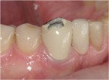
Figure 1
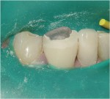
Figure 2
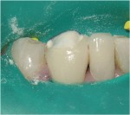
Figure 3
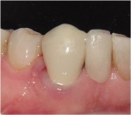
Figure 4
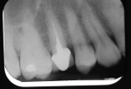
Figure 5
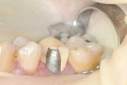
Figure 6
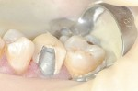
Figure 7
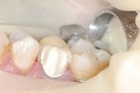
Figure 8
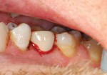
Figure 9

